



Implementation of Python Built-in Exceptions for various error conditions
LAB MANUAL

Disclaimer: The content is curated from online/offline resources and used for educational purpose only
Implementation of Python Built-in Exceptions for various error conditions

Objective:
- Learn about common Python built-in exceptions, such as ZeroDivisionError, ValueError, IndexError, and KeyError, and understand when they occur.
- Implement error handling mechanisms in Python programs using try and except blocks.
- To Understand how to catch and handle different types of exceptions using multiple except blocks.
- Write code that can handle exceptions and prevent the program from terminating unexpectedly.

Problem Statement:
- In this problem, you will explore Python’s built-in exceptions by intentionally causing different types of errors and handling them using try, except, and finally blocks. The goal is to understand how Python’s built-in exceptions work and learn to write robust code that gracefully handles common error conditions like ZeroDivisionError, ValueError, IndexError, KeyError, and more.

Equipment Required:
- Install VS Code - https://code.visualstudio.com/download
- Download Python Installer File - https://www.python.org/downloads/
Prerequisites:
- Basic Computer Skills - Anyone starting to learn computer programming needs basic computer skills.
- Basics of control statements

Procedure:
Task 1: To implement the ZeroDivisionError, ValueError, IndexError, and KeyError
Task 2: Demonstration of different exceptions

Task 1: To implement the ZeroDivisionError, ValueError, IndexError, and KeyError

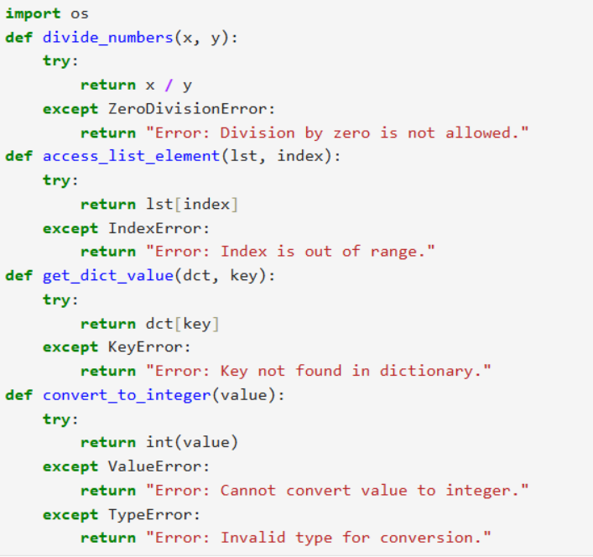

Task 2: Demonstration of different exceptions
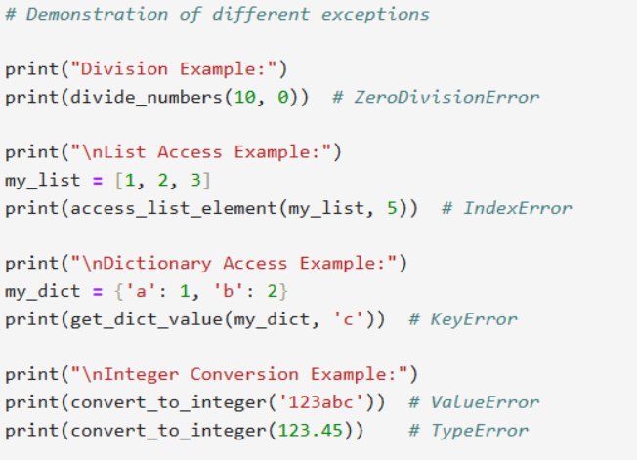
Output:
